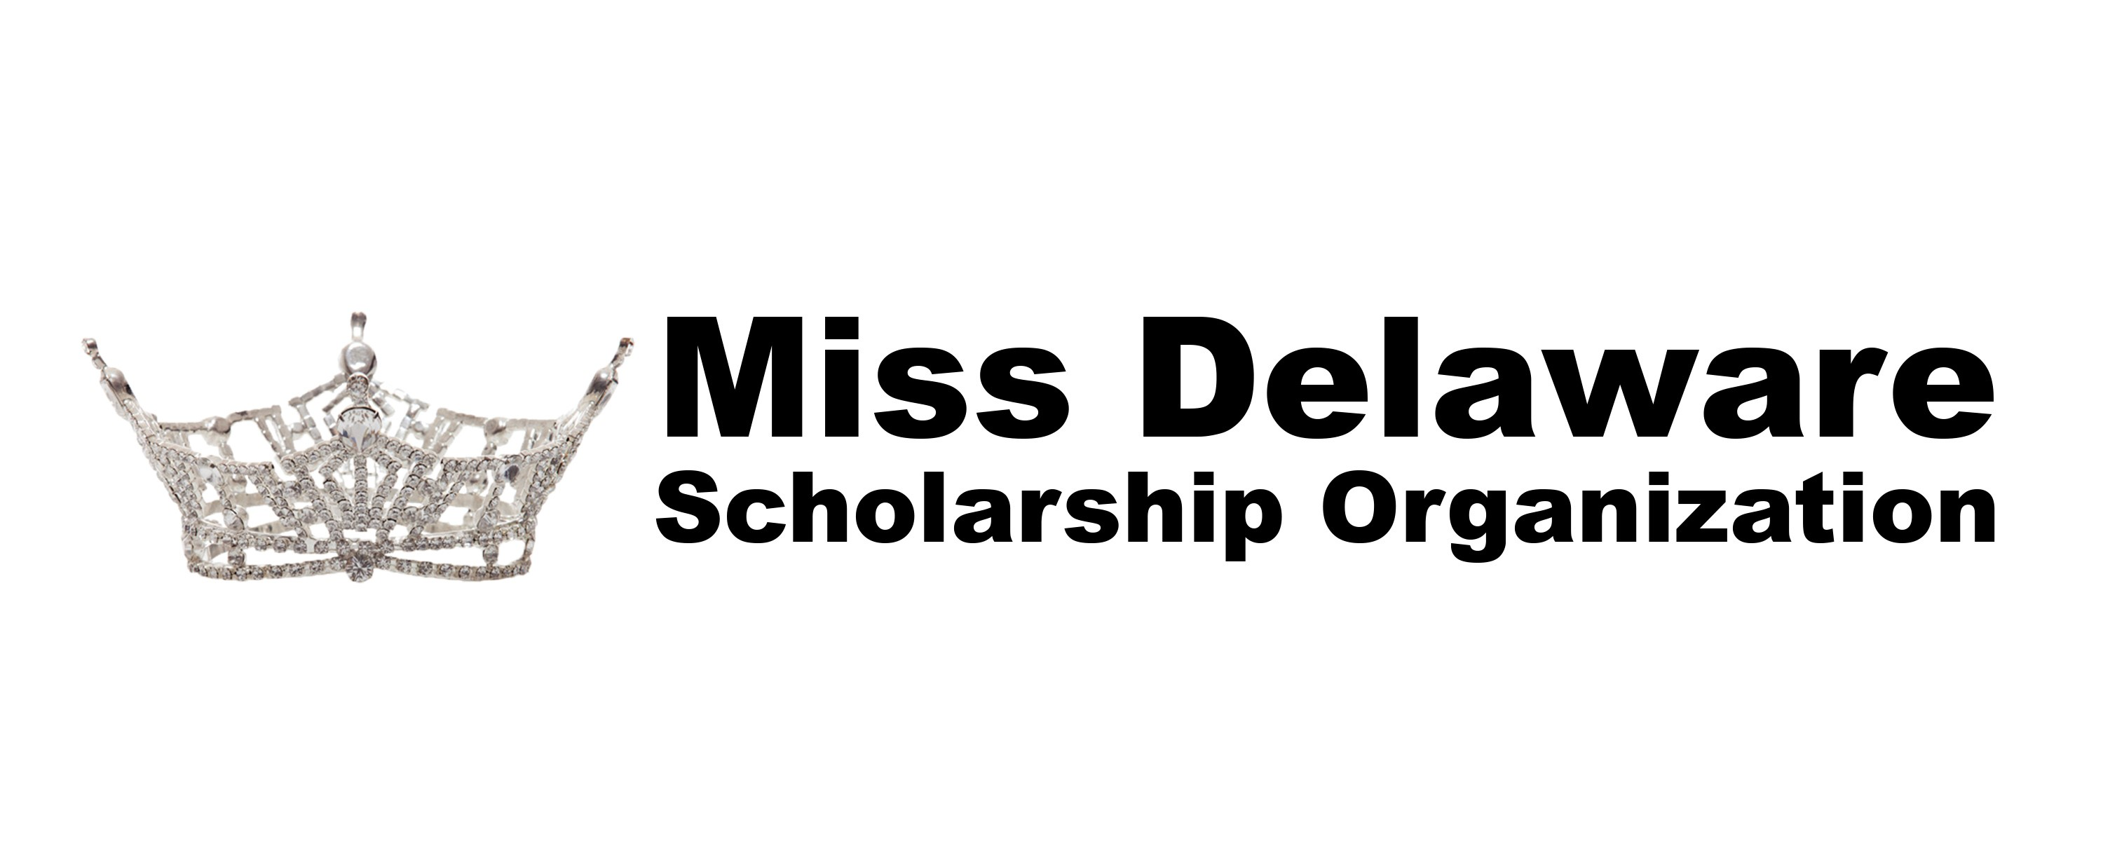 2019 Miss Delaware Scholarship Organization
Debi Wilson Community Service Award

In 2016 the Miss Delaware Organization lost a remarkable woman who dedicated over 30 years to providing education and personal growth opportunities for Delaware’s young women. To continue in these efforts the Miss Delaware Organization is announcing the new Debi Wilson Community Service Award.

This award will be given to the contestant that embraces community involvement, has been involved in activities affecting those in her community or in the State of Delaware and who champion her cause.

The first panel of community related judges will review all contestant submissions and narrow the field to the top three contestants, who will be announced at the 2019 Miss Delaware’s Outstanding Teen Pageant. Those three contestants will have the opportunity to have a 10 minute interview with the selection panel of judges. This will give finalist the chance to describe their community service efforts and explain why they should be selected for this distinguished award. Date and time of the final interview will be determined and announced later. The winner will be announced during the 2019 Miss Delaware Pageant on June 15, 2019.

Submission Requirements
Each contestant is required to submit the following information:
- Debi Wilson Community Service Award Application, limit of 1 page, see attached
- Copy of Platform Statement
- 2 Letters of Recommendation, one page limit of each, from someone who has worked closely with you or someone who has benefited from your community service work. Letters must be signed and include the address and phone number of the letter writer.
- Deadline: April 25, 2019 – No Extensions
  - Send all information (4 pages) electronically to:
    - Howard Gordon, Judges Chairperson
    - Hbgdel67@gmail.com

2019 Miss Delaware Scholarship Organization
Debi Wilson Community Service Award Application

Contestant Name
School (including Grade; ie., Senior, Junior)
Employer

List Community Services/Projects Where You Have Volunteered:
Name of Charity(ies) | How long have you been involved? | What has been your role?

Explain who has benefited from your volunteerism?

How has your community service work benefited you?

Explain your involvement.

